BIO-DATA
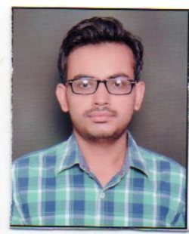
Name : Rajat Bathla

Father’s name : Sh.Satnam Das

Mother’s name : Smt.Sharda Rani

Permanent address : St.No-2,Bhagwanpura
Old Fazilka Road,Abohar
Tehsil Abohar,District Fazilka
Punjab 152116

Present address : St.No-2,Bhagwanpura
Old Fazilka Road,Abohar
Tehsil Abohar,District Fazilka
Punjab 152116

Contact No. / Mobile : +91 97808-50346

Date of birth/Age : 13 September,1990

Gender : Male

Mailing Address/E-mail : rajatbathla2010@gmail.com

Religion : Hindu

Category : General

Nationality : Indian

Marital status : Unmarried

Education qualification :
Sr.No | Name Of Exam | Board/University | Year Of Passing | % of Marks | Division
1. | SSC | P.S.E.B.Mohali | 2005 | 65 | Ist
2. | HSSC | P.S.E.B.Mohali | 2007 | 66 | Ist
3. | Graduation (B.A) | P.U.Chandigarh | 2010 | 69 | Ist

Computer knowledge : Microsoft Word & Excel
Internet and E-mail Operation

Languages Known:
Can Speak | Punjabi | Hindi | English
Can Write | Punjabi | Hindi | English
Can Read | Punjabi | Hindi | English

Experience : Fresher

Interests : Listening Music
Reading Books

Strenghts : Trust Worthy & Positive Attentive
Always willing as well as loyal to my
Work ,Eager to learn new technologies
& quick to adapt new environment

Declaration:
I hereby declare that the information given above is complete and correct to the best of my knowledge.

Date:
Place:
Signature

